FIRMWARE UPLOAD GUIDELINE

TOOLS REQUIRED
- J Link Debug Probe
- EtherCAT Interface Board and Control Board
- J link Command software (The link is for 64-bit Windows)

STEP BY STEP INSTRUCTIONS
- Download and install J link documentation pack. Inside the pack, J link commander will also be installed on the system.
- Once the software is installed, proceed to make the hardware connections between the EtherCAT Boards and the J link Debug Probe as described below
Table 1 Pinout connections between Jlink Probe and EtherCAT board
S.No | J Link Debug Probe Pin | EtherCAT Board Pin
1 | VTref | VCC_3V3
2 | SWDIO | SWDIO
3 | SWCLK | SWDCLK
4 | SWO (Optional) | SWO (Optional)
5 | RESET | RST
6 | GND | GND
- Images are also shared from both the debug probe and the board for easiness
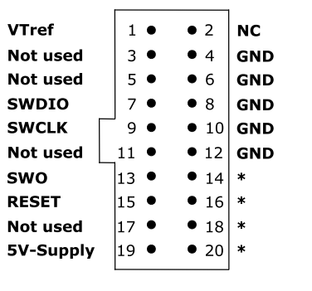
Figure 1 JLink Probe pinout information
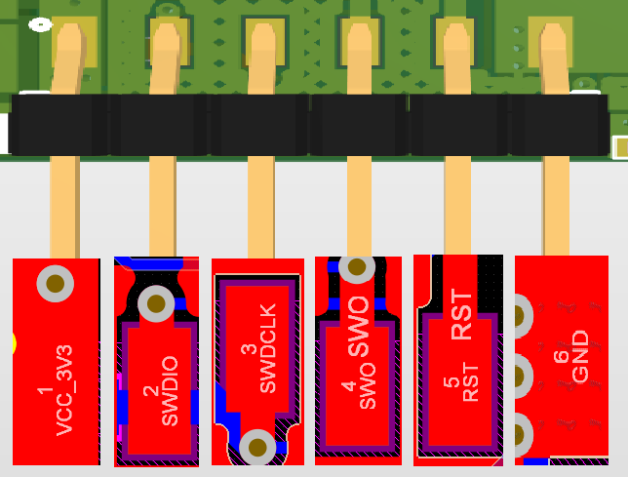
Figure 2 EtherCAT Board pinout information
- Once the connections are established, power up the PCB board using the headers on Interface Board with an adequate power supply.
- Connect the J link to the target PC and then afterwards open Jlink commander software.
- Verify VTref are being read as 3.3V to make sure the board is properly connected to the Jlink Probe as shown in Figure 3
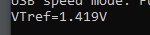
Figure 3 Screenshot showing VTref for unconnected Jlink
- Type connect on the command line interface to establish connection with the custom EtherCAT board.
- Once the connection is established, an interface may open where it will ask for specific MCU part number, proceed to select ATSAME53J18 from the list and click OK.
- Another prompt will ask for type of Interface? (SWD, JTAG etc). Type S and press Enter to proceed.
- Choose default for the rest of the options by pressing Enter.
- Once finished, type loadfile <path\to\hex\file>
- Press Enter and the program will start to load. Once the program has loaded successfully, an On-screen message will indicate success.
- Disconnect the Jlink Probe and power cycle the board (turn the power OFF / ON) and start testing!

